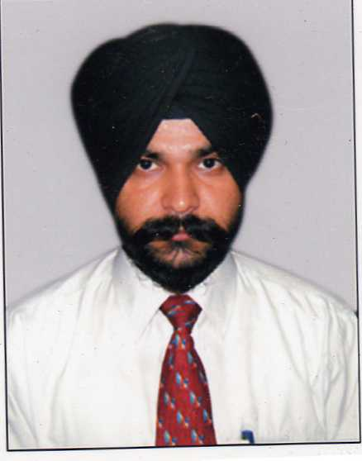
JAGDEEP SINGH
Address: 82- A Vikas Vihar/Dalip Vihar, Nelothi Extn, Nangloi, New Delhi-110041, INDIA
Contact No: +91- 9810570440 (Mob)
E-mail: jagdeep.singh@live.in ; jagdeep18051976@gmail.com;
WORKING EXPERIENCE :More than 21 year experience in maintenance and refurbishment of aircraft ground support equipment or Heavy/Medium/ Light Equipment and vehicles (HMV* to LMV* equipped with different engines like; Diesel/ Petrol/ CNG/LPG or Electrical & other system like Hydraulic, Mechanical, Electrical, Pneumatic, Transmission (auto & Manual)
- Presently working with millennium aero dynamic as leading of refurbishment/Maintenance of GSE and working on TaxiBot India from Aug 2019 to till date as a DGM ( Consultant)
- Also start our Company as GSE ASE Maintenance and Manufacturing as proprietorship Mar 19

Refurbish equipment list, TLD -TMX 150-12, ASU 600, Schopf F396 Trepel MDL, Airmarrel LDL

Company certified from ISO 45001:2018,CE, ISO 6966-2:2014, AS 9100:2016 REV (D), IATF 16949:2016, ISO 9001:2015.
From Feb 15 – Mar 19 working with M/s Interglobe Aviation ltd (Indigo airline) , T-1, 2, 3. IGI Airport, New Delhi as Asst-Manager Ground support dept pan India. GSE Maintenance, and Refurbishment of old equipment. from 12st FEB 2015.
Aug 2013 to Feb 2015 working with M/s Aviaxpert Pvt. Ltd. IATA Approved, T-1, 2, 3. IGI Airport, New Delhi as Manager Ground support dept. GSE Maintenance Dept.
- Give all Equipment maintenance tanning. Providing complete GSD Operation & Maintenance setup.
- Commissioning and Service engineer for Airmarrel
- Commissioning and Service engineer for TUG TECH USA Tractors
part time working as a Trainer with Yog-kshem commerce Pvt. Ltd. ISO 9001:2008 CERTIFIED COMPANY also FAA approved.
- Give Equipment Operating training & SOPs of Equipment to our client Like Buddha air in Kathmandu, Nepal.
- Give Equipment maintenance tanning. Providing complete GSD Operation & Maintenance setup.
- Adviser of ground support equipment.
Nov 2012 to 31st July 2013 Capital hydraulic industries Pvt. Ltd. New Delhi.
- Maintenance Engineer for all type of GSE and Construction equipment.
Aug 2009 – 31st Oct 2012 BWFS India (Pvt) Limited, IGI Delhi Airport.
- Jul 2011- Till date: Head-Technical Services for Ground Support Equipment.( Major work and Refurbishment of Trepel mdl, Schopf f396, FMC ldl etc
- Aug 2009-Jul 2011: Duty Manager in Ground equipment operations & maintenance.
Jul 2005- Jul 2009: Kingfisher Airlines Limited, IGI Delhi Airport.
- Mar 2009- Jul 2009: Ground Support Supervisor in Engineering Department.
- Jul 2005- Feb 2009: Ground Support Agent in Airport Services Department.
Jul 2000- Jun 2005: Globe Ground India (Pvt) Limited
- Jun 2003- Jun 2005: Technician cum Operator
- Jan 2001- May 2003: Junior Technician cum Operator
- Jul 2000- Dec 2000: Trainee Technician cum Operator
JOB RESPONSIBILITIES:
- Preventive, periodic, breakdown and in-depth maintenance of ground support equipment and vehicles.
- Inspect equipment to detect faults, malfunctions and major maintenance on engines like Deutz, GM, Kirloskar, Mann, Perkin, Cummins, Caterpillar, International Harvester, Detroit, Tata, Suzuki, Honda etc.
- Worked on heavy equipment like Push back tractors, Main Deck LOADERS, Lower Deck LOADERS, Bulk Freight LOADERS, Fork Lifts, Step Ladders, Jet Starter Units, Air Conditioning Units, Ground Power Units, Man Lift or Cherry Pickers etc.
- Diagnose faults or malfunctions using computerized and other testing equipment like OBD’s.
- Adjust equipment and repair or replace defective parts, components or systems, using hand and power tools.
- Repair equipment for proper performance and to ensure that work meets manufacturer’s specifications.
- Re-conditioning or Re-fabrication of old equipment.
- Inventory control & spare procurement (including stores & service records).
- Liaising with outsource agencies & vender for spares.
- Giving SOP’s training for all aircraft equipment to Operators including emergency operations during failure.
**: Heavy Motor Vehicles/ Light Motor Vehicles
- Giving SOP’s training for all aircraft equipment to Operators including emergency operations during failure.
- Familiar with heavy equipment hydraulic systems, motors, pumps, hydraulic cylinders, coolers, solenoid or Valves etc.
- Knowledge of operating all equipment on aircrafts like Boing-747/737/777, Airbus-380/340/330/320/319/318/310, MD-11/10, ATR, CRJ, Beach Craft etc.
TECHNICAL QUALIFICATION
ITI: Two year certificate course in Mechanic (Motor Vehicle) from National Council for Vocational training, Govt. of India in the year 1995-97 securing 86 % marks.
Apprenticeship: Apprenticeship in Mechanic (Motor vehicle) trade under Apprentice act 1961 from Air India, IGI Delhi Airport. (Apprentice period: Nov 1998-Feb 2000)
Auto Electrician: 3 months course of Auto Electrician from Delhi. (Feb 1998-May 1998)
Training Abroad: Obtained high profile training of Pushback maintenance from TLD Asia, Shanghai, China in Dec 2007.
: Obtained professional training for maintenance and commissioning of AIRMARREL FRANCE for
LAM 7000 DP (Lower deck loader) and LAM 27000DP ( Main deck loader)
: Obtained professional training for maintenance and commissioning of TUG Technology USA for electric baggage tractor MZ and Pushback tractor GT-35
ACADEMIC QUALIFICATION
Matriculation from CBSE Delhi board in year 1994.
12th from U.P board in 2006.

PERSONAL
Father’s Name : Shri Baldev Singh
Date of Birth : 18th May 1976
Marital Status : Married
Languages Known : English, Hindi, Punjabi.
Interests : Soccer, Watching TV, Reading Technical Manual.
License : HMV Valid
Passport : Valid

Date: AUG 2021 ___________________________
Place: New Delhi ( Jagdeep Singh )

